FOR IMMEDIATE RELEASE · JUNE 5, 2026
Xvaluator QuAI
Made in France · Made in Europe — La Révolution Souveraine de l’IA
Founded Dec. 1, 2015 · Patent FR1657516 · 2019 · Issy-les-Moulineaux, France
Valuation >€300M — Audit A.Kaiser, Paris 2026 · 10+ years R&D · 3rd AI Paradigm — Cognitive Sciences
ACN Observatory 2026 — p. 74 · ISTE Open Science 2026 · Patent FR1657516

“The Cybersecurity of the Future Will Be Built on Qualified Data — Or It Will Not Exist”
Xvaluator QuAI cited in the ACN 2026 Trusted Digital Observatory (p. 74) and validated by a new ISTE Open Science chapter — France's sovereign deep-tech breakthrough positions Qualitative AI as the essential third layer of global artificial intelligence.
Issy-les-Moulineaux, Grand Paris · June 2026

“L’IA Qualificative Xvaluator : révolutionner la confiance numerique et écologique” janvier 2025
(https://sodigital.fr/xvaluator/)

1. CONTEXT

A Radically Different Answer to the AI Crisis of Trust
In an ecosystem where OpenAI burns more than $27 billion per year and Anthropic has raised $72 billion with a deeply negative EBITDA, the race for large language models consumes colossal resources without addressing the core challenges of trust, ethics, and ecological footprint. A sovereign French innovation proposes a fundamentally different path: Xvaluator, and its Qualitative AI (QuAI) — a third category of artificial intelligence, patented in France in 2019 (FR1657516) and recognised by the international scientific community as a new paradigm in cognitive sciences.

Founded on December 1, 2015 and independently valued at more than €300 million in 2026 ahead of its planned scale-up in 2027, Xvaluator’s strategy is unique: not to compete with AI giants, but to embed within their tools to make them more relevant, more ethical, and more ecological. Its frugal architecture requires no massive GPU farm and projects an EBITDA margin above 90% at maturity — structurally impossible for competing LLMs.

2. THE THIRD AI PARADIGM

Qualitative AI — Neither Symbolic, Nor Connective
Since the 1950s, AI has been told in two chapters. Xvaluator opens a third, founded on rigorous economic and mathematical theory.

Criterion | Symbolic AI | Connective AI (GenAI) | Qualitative AI (QuAI)
Paradigm | Formalised human thinking — explicit knowledge, deductive logic | Neural networks, statistical learning, LLMs | Qualified aggregation of collective preferences, human-machine consensus
Pioneers | Turing, McCarthy, Minsky, Newell & Simon | LeCun, Hinton, Bengio, Hopfield (Nobel Physics 2024) | Condorcet, Arrow (Nobel), Stiglitz (Nobel), Sen (Nobel)
CO₂ / query | Low | Very high (GPT-4 ~10g CO₂/req.) | Minimal — patented frugal architecture
Relation to others | Competes with connective AI | Competes with symbolic AI | Embeds in all — enhances all
Key limit | Rigid under uncertainty | Bias, hallucinations, opacity, massive CO₂ | Complementary layer — no intrinsic limitation

Source: Paun & Vaileanu-Paun, ISTE Tech&Inn 2025 [3] · Springer Encyclopedia [2]
“After the purely symbolic path of expert systems, then the purely connectionist path of neural networks, AI is now taking a third hybrid path. QuAI introduces elements of human reasoning mechanisms into AI models, going beyond mere imitation of reasoning effects. Inspired by social choice theory, this approach bypasses the Condorcet paradox through Borda-weighted aggregation methods — the model then behaves like a collective expert.”
— Pr. Nicolas Curien, Académicien, Académie des Technologies de France [1]

3. TECHNOLOGY

The Xvaluator QuAI Ecosystem
The platform rests on three integrated components that together enable real-time data qualification and participative consensus-building. Supported in part by the E-DIH Paris-Saclay (CEA — European Digital Innovation Hub). [21]

Digital Wallet  Consultation tool for optimal decision-making across stakeholders | Like Fingerprint©  Patented technology that structures & protects data — GDPR compliant
Data Lake  Centralisation and qualification of reviews for informed decision-making | Real-time & continuous  Aggregates opinion & impact data from all platforms and social networks

4. OFFICIAL RECOGNITION

ACN 2026 Trusted Digital Observatory & ISTE Open Science
The Alliance pour la Confiance en Numérique (ACN) cites Xvaluator on page 74 of its Observatoire 2026 de l’IA de Confiance. A new scientific chapter simultaneously published by ISTE Open Science further validates the framework:

QuAI: Cognitive AI for Trust, Consensus, Sustainability and Security
Paun, F., Vaileanu-Paun, I., Leaua, C., O’Neal, T., Jaso, A., Chaudron, L. — ISTE Open Science, 2026
https://www.iste.co.uk/book.php?id=2359

ACN Observatory 2026 — Full Report (Xvaluator cited p. 74)
Alliance pour la Confiance en Numérique, Paris, 2026
https://www.confiance-numerique.fr/wp-content/uploads/2026/06/Observatoire-ACN-2026-de-la-confiance-numerique-bd.pdf

5. MARKET CONTEXT

French Digital Trust Industry — 2025 Key Figures

€34.7B  Global revenue (+5.4% growth) | €22.4B  French revenue (incl. €6.8B exports)
174,900  Sector professionals worldwide | 8%  Trusted AI share — fastest-growing segment
€300M+  Xvaluator valuation — Audit K, Paris 2024 | ~$2T  Total addressable market (universal AI layer)

As a universal complementary layer that enhances — rather than competes with — all existing AI systems including those from OpenAI, Anthropic, Mistral and xAI, Xvaluator addresses a structurally larger market than any single major AI player. An IPO is targeted within 5 years with a projected ×30 ROI based on the official valuation in june 2026 https://www.interviewfrancophone.net/_files/ugd/53b505_68d9ed14b4864cb1832d9f73840dcd0c.pdf (Surce: https://www.interviewfrancophone.net/xvaluator-investisseurs)

6. FOUNDERS

Scientific & Institutional Credibility

Dr. Florin Paun — Founder & Inventor
Chevalier de l’Ordre National du Mérite · Former Head of Innovation & Technology Transfer, ONERA (French national aerospace research centre — equivalent of NASA) · Trained at Polytechnique, ISAE Toulouse, and MIT Sloan (Leadership) · TEDx Bucharest speaker · Expert, EIC European Innovation Council · Google Scholar H-index 13 / i10-index 14 · Author of 5 books including the first ScienceFictionAI novel · Honorary Citizen of Alba Iulia, Romania.

Dr. Paun has extended the theoretical frameworks of Nobel laureates Joseph Stiglitz and Amartya Sen, identifying multiple asymmetries (cultural, temporal, interest-related) as new locks on collaborative innovation. He introduced the DRL — Demand Readiness Level, completing NASA’s TRL to hybridise Tech-Push and Market-Pull approaches. [6]

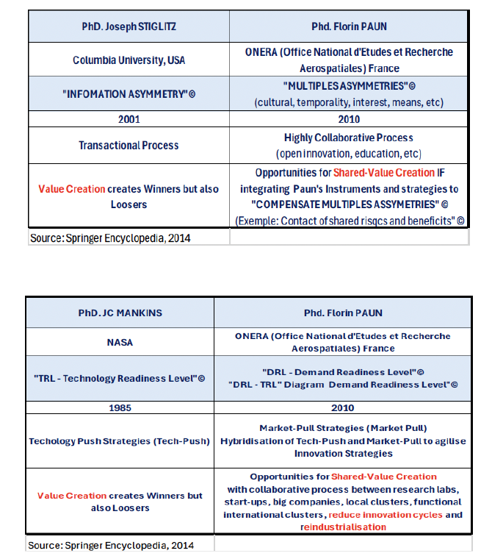

Ingrid Vaileanu-Paun — Co-Founder & Economist
Author of France’s first doctoral thesis in functional economy · Université Paris Diderot · CIFRE scholarship in partnership with EDF and the French Government (Bourse CIFRE) · Her research scientifically proved the consubstantiality of evolutions in economic, innovation, and valorisation models — the theoretical foundation of Xvaluator’s co-evaluative approach · Springer Encyclopedia contributor (co-evaluation, 2013). [8]

7. INSTITUTIONAL VOICES

Recognition Across Science, Government, Finance & Industry

“As the founder of Xvaluator, whose Qualitative AI completes the theories of Condorcet and Arrow, Dr. Florin Paun has helped open the path towards reducing the ecological footprint of AI and strengthening digital trust.”
— Jean-Luc Moudenc, Mayor of Toulouse, President of Toulouse Métropole [7]

“I learned, during my mission aboard Soyuz-40 to the Salyut 6 orbital station, that genuine technological progress does not mean replacing the human being, but augmenting their capacity for judgement and responsibility. QuAI represents an attempt to bring AI closer to human deliberative logic.”  — Dorin Prunariu, Cosmonaut, Romanian Academy & International Astronautics Academy [9] | “Xvaluator allows the city to deploy new methods to protect itself from bot attacks and to fight against the ecological footprint of its digital use with less energy-intensive generative AI.”  — Eric Legale, Director General, SEM ISSY MEDIA — Ville d’Issy-les-Moulineaux [13]
“The value proposition centred on reducing the ecological footprint of generative AI and building digital trust solutions represents a major advance. We are pleased to recommend Xvaluator for funding.”  — Maximilien Nayaradou, Director General, Pôle Finance Innovation — Paris Europlace [15] | “"The IME seeks to integrate AI tools such as Xvaluator into the entrepreneur support process and to explore innovative French solutions for augmented mentoring — enabling the real-time, continuous, and qualified integration of feedback from all of an entrepreneur's stakeholders — with the goal of accelerating market anticipation processes, fostering open innovation, improving customer relationships, and securing and engaging investors."  — Fabrice Geffroy, General Delegate, IME France — National network of high-growth SMEs · Letter of Interest [17]
“"Moovjee aims to allow its members and stakeholders to freely experiment with innovative solutions tailored to their needs. More specifically, the collaboration with Xvaluator will enable co-innovation and the development of digital tools useful to the network for measuring entrepreneur performance, anticipating risks, and adapting offerings based on real-time perceived value."  — Bénédicte Sanson, General Delegate, Moovjee — Over 60,000 entrepreneurs and their stakeholders · Letter of Intent [18] | “The Participative Evaluation Platform Xvaluator offers a common co-evaluation space — a concept recognised by the scientific community (Springer Encyclopedia, Vaileanu-Paun, 2013).”  — Christian Pierret, Former Minister, President, Fédération des Villes Moyennes [14]
“La proposition de valeur centrée sur la réduction de l’empreinte écologique des usages de l’IA générative nous semble présenter des avancées majeures. Nous souhaitons être parmi les premières entreprises à expérimenter ces outils innovants.”  — Said Sahardeed, General Manager, Marcus Evans International [20] | “La deeptech IA Qualificative Xvaluator apporte des solutions d’évaluation du business model en cohérence avec l’économie de la fonctionnalité pour la qualification participative des données.”  — CEA Paris-Saclay, E-DIH — European Digital Innovation Hub [21]

8. VALIDATION NETWORK

International Scientific & Institutional Recognition

Springer Encyclopedia · ISTE Open Science 2026 · ACN — Alliance Confiance Numérique · Romanian Academy · Lugano AI Summit 2025 · NATO (prospective) · Pôle Finance Innovation · Paris Europlace · French Federation of Cities · CEA Paris-Saclay E-DIH · Pôle Systematic Paris-Region · BNP Paribas · Ville d’Issy-les-Moulineaux · France Deeptech · IME France · TED-X · Marcus Evans International · Moovjee (60,000+ entrepreneurs)

9. GLOBAL ALIGNMENT

Natively Aligned with the World’s Key Frameworks
Xvaluator is natively compliant with:

• EU AI Act (2024)
• Rome Call for AI Ethics — cosigned Pope Francis, Microsoft, IBM
• Paris Agreement on Climate
• UN Sustainable Development Goals: SDG 9 (Innovation), SDG 13 (Climate), SDG 16 (Justice), SDG 17 (Partnerships)
• GDPR compliant

Xvaluator targets at least 30% of AI and digital users becoming active XVALUATORS — practitioners of open, participatory data qualification. An IPO is targeted within 8 years with a projected ×30 ROI based on the official 2024 valuation.

MEDIA CONTACT

Ingrid Vaileanu
Editor-in-Chief, Co-Founder — Xvaluator & Interview Francophone
Email: news@interviewfrancophone.net
Phone: +33 6 85 43 27 89
Location: Issy-les-Moulineaux, 92130, France
Web: www.interviewfrancophone.net · sodigital.fr/xvaluator · florin-paun.com

ABOUT INTERVIEW FRANCOPHONE
European accredited publication, member of the Foreign Press Association (APE) in Paris since 2004. 300+ MAE-accredited media outlets across 28 diaspora communities in 42 countries. Over 1 million global readers. Organiser of the annual International Summit of Scientific and Innovation Diasporas (Paris — Sénat / Palais Brongniart), which has welcomed Nobel laureates, Heads of State, the President of the World Bank (2025), and the Managing Director of the IMF.

— END OF PRESS RELEASE —

